# 5 Biggest Big Data Challenges

Source: <https://bleuwire.com/5-biggest-big-data-challenges/>

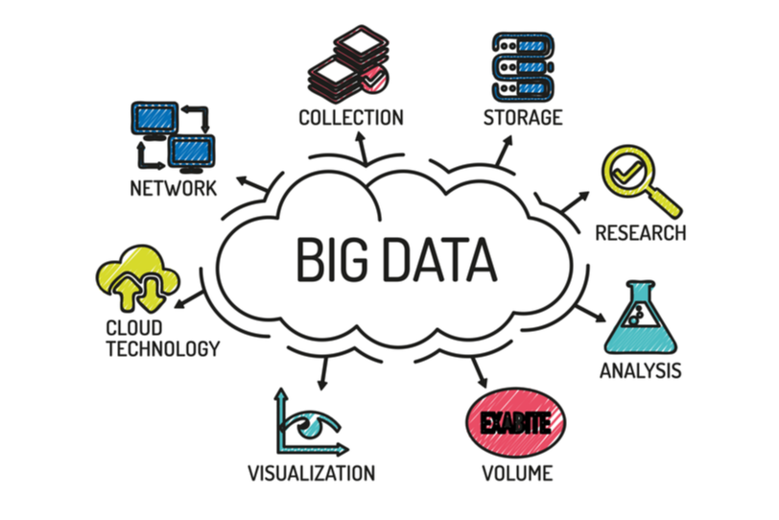

Big data is becoming more famous with time. Companies are using it for increasing their business efficiency. Affording to a recent survey by NewVantage, more than 95% of the Fortune 1000 business firms are working on a [big data project](https://bleuwire.com/5-biggest-data-center-trends-2019/). But, only 48% said that they have achieved satisfactory results from their big data projects. Only 15% of these businesses are deploying their projects to production. There are various challenges that you need to deal with.

Companies are generating a lot of data every day. Big data is allowing companies to analyze and capture this data. They are using this data for making better business decisions. Also, big data is helping companies in improving their operations and becoming more competitive. But, there are various challenges that you need to overcome. In this article, we are going to talk about 5 big data challenges.

## Insufficient knowledge

Most of the companies don’t even know the basics of big data. They also don’t know the [benefits of big data](https://bleuwire.com/4-benefits-business-intelligence-platform/). If you don’t have a clear understanding, then your big data project will fail. Companies are wasting a lot of resources and time on technologies like big data. But, they don’t even know the basics of these new technologies. Most of your employees also don’t understand the true value of big data. Thus, they are not willing to change their existing processes. This can cause serious damage to your company process.

Big data is a huge step for any company. First, it should be accepted by the board members of your company. They should understand the basics of big data. After that, you need to ensure that your employees also know about big data advantages. Your IT team can organize workshops and training. This will help you in training your employees. You can also increase the big data acceptance by monitoring your employees. However, this can also have negative effects on your employee productivity.

## Expensive

Big data projects are expensive for most of the companies. If you are using an on-premises solution, then you need to invest in new hardware. Also, you need to hire new developers and administrators. Most of the frameworks are free and open-source. But, you still need to pay for the configuration, maintenance, setup and development of your new project.

You can also opt for a cloud-based solution. If you are using a [cloud-based solution](https://bleuwire.com/how-can-we-help/cloud-computing-solutions/), then you need to pay for cloud services only. But, you still need to hire skilled people to develop your product. Both of these options are expensive.

If you want more flexibility, then you should opt for a cloud-based solution. It will allow you to easily scale up your resources. But, if you are looking for more security, then you should go for an on-premises solution. Some companies are also using [hybrid solutions](https://bleuwire.com/why-hybrid-cloud-perfect-for-sme/) for developing their products. Their sensitive data is stored in their own storage facility. But, they are using cloud computing power for processing their data. This is perfect for companies that are looking for a cost-effective option.

## Difficult to manage data quality

Data integration is one of the biggest challenges that you need to overcome. Your software will collect data from various different sources. For example, it can collect data from call-centers, website logs, and social media. The data format of this data will differ. Hence, it is difficult to integrate all this data.

Also, the big data can’t guarantee 100% accuracy. You need to make sure that it is collecting only reliable data. Sometimes you can collect wrong or duplicate information. This type of data is not useful for your organization.

You can improve this by cleansing your data. First, you should work on creating a proper big data model. After that, you must focus on comparing your data with each other. If some record is already available, then you should merge both records. This will help you in increasing the accuracy of your big data model.

## Security holes

Big data can open various [security holes in your network](https://bleuwire.com/improve-it-security-limited-budget/). Most of the companies don’t care about security when they are launching their big data project. But, this is not a smart move. Big data is evolving with time. Still, it lacks many security features. You can deal with this by focusing more on security.

## Upscaling

The most important feature of big data is that it grows with time. This is also the most serious challenge of dealing with big data. Most companies think that they can upscale their projects by [increasing their storage capacity](https://bleuwire.com/enterprise-data-storage-101/). They focus on increasing their computing power. But, it is still difficult to upscale without declining your system performance. Every company has a limited IT budget. Thus, you need to ensure that you are staying within your budget.

You should focus on having a decent architecture for your solution. This will help you in upscaling your project in the future. If your big data solution has good architecture, then you don’t need to worry about most of the challenges. Your algorithm should be designed by keeping the upscaling in mind.

You also need to do proper planning for your [system support and maintenance](https://bleuwire.com/the-importance-of-third-party-maintenance/). This will help you in dealing with the upscaling problem. Also, you should regularly check the performance of your system. This will help you in identifying weak spots in your system. Thus, you can address them on time.

## Conclusion

Big data is very important for most of the organizations. It will help you in [collecting and analyzing your organization data](https://bleuwire.com/cloud-cost-optimization-efficient-ways-to-reduce-costs/). This will help you in making better business decisions. But, there are many challenges that you need to overcome. If you have a good architecture for your solution, then you can easily deal with these problems. You should take a systematic approach to deal with these challenges. But, you should also hold workshops for your employees. This will help you in increasing big data adoption. If you want more information about big data, then you can contact Bleuwire.